|  |  |
| --- | --- |
|  |  |
| Point Of Sales System |  |
|  |  |
|  | 2023Full stack web development -PHP |
|  | Mohammad Odeh |

Introduction

* Purpose :

The objective of point of sales system is allow users to handle the store sales transactions and stock according to them roles, the admin user can access everything, the seller user can only create transaction

read, edit, and delete them , the procurement user can read, create, edit, and delete items, the accountant user can only read transaction and edit them, the website is designed on MVC design pattern with modern PHP content management system.

* aspects of the solution :

create a web application with modern user interface contains pages that handle the operations requested in the scenario such as modern responsive login page with only CSS used , selling dashboard page fully developed by using AJAX request in jQuery , modern dashboard that contains useful information to users, transaction page will be used by accountant user to check up the operations, stock management page to allow procurement user to add new items, finally user management page to let admin control the user permissions and roles in web application.

* Design pattern :

the application is designed on MVC pattern , the classes used :

1. Model : the model class contains only pure application data only describing how to present the data to user.
2. View : present model data to user in HTML and CSS.
3. Controller : the controller exists between the model and view It listens to events triggered by the view and executes the fit reaction to these events. In most cases, the reaction is to call a method on the model. Since the view and the model are connected through a notification mechanism, the result of this action is then automatically reflected in the view.

* Workflow of system :

Shown in following figure 1.1.

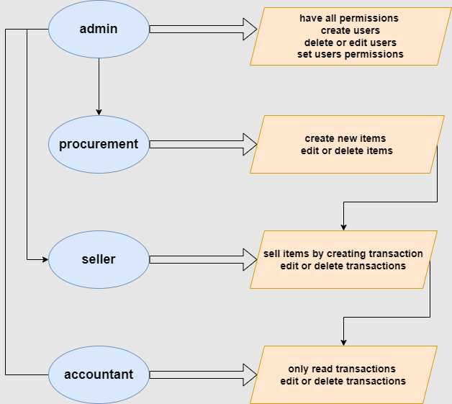

Figure 1.1

* References :
* www.geeksforgeeks.org
* app.diagrams.net